**Model Development Phase Template**

|  |  |
| --- | --- |
| Date | 05 july 2025 |
| Name | Sanika Tanaji Patil |
| Project Title | Restaurant Recommendation System |
| Maximum Marks | 10 Marks |

**Initial Model Training Code, Model Validation and Evaluation Report Initial Model Training Code (5 marks):**

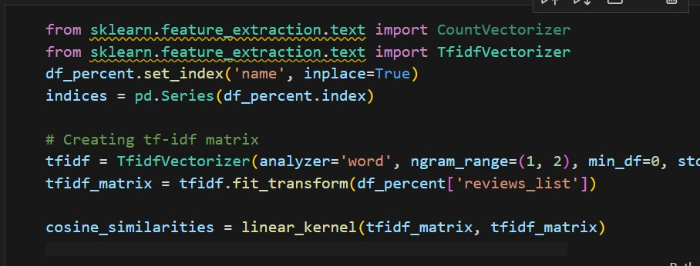

**Model Validation and Evaluation Report (5 marks):**

|  |  |  |
| --- | --- | --- |
| **Model** | **Summary** | **Training and Validation Performance**  **Metrics** |
| Model 1 | Content-based Recommendation | **Training Metrics -**None (unsupervised, no explicit training phase)  **Validation Metrics -** None  (recommendations are inspected manually) |